Guided Practice Report
Before completing this guided practice report, you should have completed the associated procedure.

Screenshots
After you have completed the procedure for the guided practice, add your screenshots below.
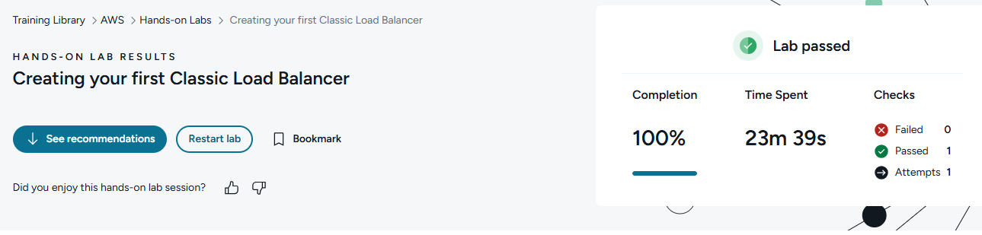

Reflection Questions
After you have completed the procedure for the guided practice, provide your answers to the reflection questions here.
What function does an AWS classic load balancer serve?
An AWS Classic Load Balancer distributes incoming traffic across multiple resources, such as EC2 instances.

How does this function benefit users who are accessing AWS load-balanced resources?
This benefits users by improving availability and performance. If one server is busy or unhealthy, traffic can be sent to another healthy server.

What is the purpose of a designated listener as it relates to load balancing?
A listener checks for incoming requests on a specific protocol and port, such as HTTP port 80 or HTTPS port 443, then forwards that traffic to the correct back-end resource.

